

**NATIONAL CERTIFICATE**

# FITTING AND MACHINING THEORY N2

(11022032)

**6 April 2020 (X-paper)**

**09:00–12:00**

**Calculators may be used.**

**This question paper consists of 8 pages and 1 formula sheet.**

## 104Q1A2006

### DEPARTMENT OF HIGHER EDUCATION AND TRAINING

**REPUBLIC OF SOUTH AFRICA**

NATIONAL CERTIFICATE

FITTING AND MACHINING THEORY N2

TIME: 3 HOURS

MARKS: 100

NOTE: If you answer more than the required number of questions, only the required number of questions will be marked. All work you do not want to be marked, must be clearly crossed out.

#### INSTRUCTIONS AND INFORMATION

1. Answer all the questions in SECTION A, except for QUESTION 1 where you must answer either QUESTION 1.1 OR QUESTION 1.2.

1. Answer any TWO of the three questions in SECTION B.

1. Read all the questions carefully.

1. Number the answers according to the numbering system used in this question paper.

1. Write neatly and legibly.

**SECTION A**

#### QUESTION 1: OCCUPATIONAL SAFETY

Answer QUESTION 1.1 OR QUESTION 1.2.

1.1 State FIVE characteristics of an effective machine guard.

 OR

1.2 State FIVE precautions that must be adhered to in preventing underground

fires.  **[5]**

#### QUESTION 2: COUPLINGS

Choose a term from COLUMN B that matches a description in COLUMN A. Write only the letter (A–H) next to the question number (2.1–2.6) in the ANSWER BOOK.

|  |  |  |  |
| --- | --- | --- | --- |
|  | **COLUMN A** |  | **COLUMN B** |
| 2.1      2.2      2.3      2.4      2.5      2.6 | The force responsible for transmitting drive from one rotor to another in a fluid coupling    An elastic torsion coupling that is suitable for most applications    A coupling that insulates the motor electrically from the machine    Connects shafts of which the axes are at an angle other than 180°    Has a spigot and recess to allow for perfect alignment    Transmits torque through an oil-resistant rubber | A    B    C    D    E    F    G    H | universal coupling    rubber belt coupling    gravitational force    centrifugal force    spider coupling    Raffard coupling    nylon sleeve coupling    flange coupling |

#### (6 × 1) [6] QUESTION 3: LIMITS AND FITS

3.1 A deviation on holes and shafts are indicated by capital and small alphabetical letters.

What do the following letters indicate?

 3.1.1 b

3.1.2 A

(2 × 1) (2)

3.2 Name THREE basic classes of fits. (3)

3.3 State TWO factors that influence interference fits. (2)

**[7]**

**QUESTION 4: BEARINGS**

State FIVE causes of failure in *plain bearings*.  **[5]**

#### QUESTION 5 : LUBRICATION AND VALVES

5.1 Explain what is meant by the following lubrication terms:

5.1.1 Rubbing pressure (1)

 5.1.2 Cold point (1)

5.1.3 Adhesion (1)

5.2 FIGURE 1 shows a diagram of a valve.

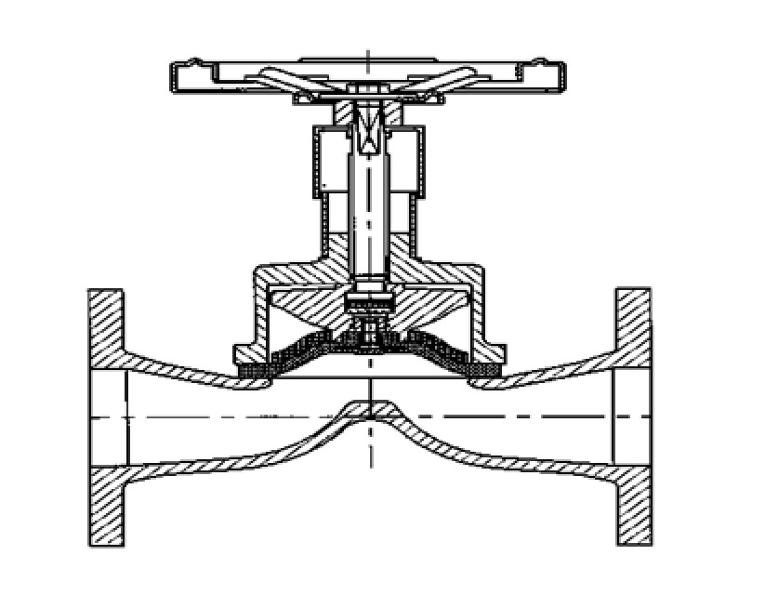

**FIGURE 1**

5.2.1

Name

the valve in FIGURE 1.

(1)



5.2.2 Explain the working principle of this valve. (2)

**[6]**

#### QUESTION 6: PACKING, STUFFING BOXES, JOINTS AND WATER PIPE SYSTEMS

6.1 State FIVE characteristics of the rubber that is used as packing and seals. (5)

6.2 State where each of the following fittings may be used in a water pipe system:



6.2.1 Plug

6.2.2 Cap

6.2.3 Nipple

6.2.4 Socket

(4 × 1) (4)

**[9]**

#### QUESTION 7: PUMPS

7.1 Name TWO types of rotary pumps (2)

7.2 What type of pumps are piston and plunger pumps? (1)



7.3 Name THREE components of a centrifugal pump (3)

|  |  |
| --- | --- |
|  | **[6]** |
| **QUESTION 8: COMPRESSORS** |  |
| FIGURE 2 shows a diagram of the operation of a single-stage reciprocating compressor. |  |

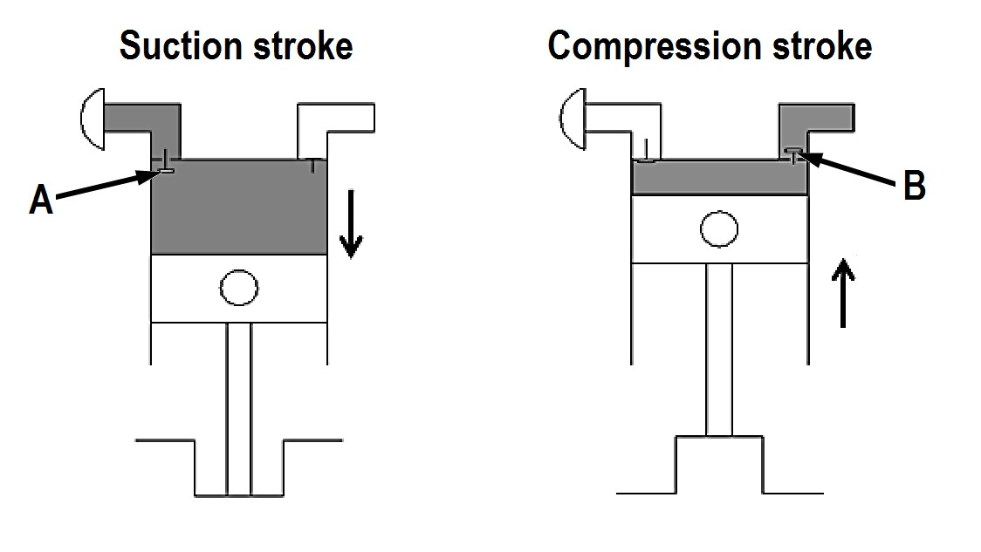

#### FIGURE 2

8.1 Name the components labelled A and B. (2)

8.2 State the operation of this compressor during the compression stroke. (2)

**[4]**

#### QUESTION 9: V-BELTS, GEAR DRIVES, CHAIN DRIVES AND REDUCTION GEARBOXES

9.1 State FOUR advantages of *belt drives* compared to *chain drives*. (4)



9.2 Explain why a gear drive is referred to as a positive drive. (1)

9.3 State the influence that an idler gear has on the velocity ratio of a gear train. (1)

9.4 State the FOUR factors to be taken into consideration when determining

chain length. (4)

9.5 Explain TWO functions of a reduction gearbox. (2)

**[12]**

**TOTAL SECTION A:**   **60**

**SECTION B**

Answer any TWO of the three questions in SECTION B.

#### QUESTION 10: HYDRAULICS AND PNEUMATICS

10.1 Name FIVE basic components in a pneumatic system. (5)



10.2 State the THREE main functions of oil in a hydraulic system. (3)

10.3 Name the TWO most important factors in the functioning of a pneumatic

system. (2)

10.4 Explain the functions of the following components of a hydraulic system:

10.4.1 Reservoir

10.4.2 Pressure relief valve

10.4.3 Control valve

 10.4.4 Actuator

10.4.5 Piping

(5 x 1) (5)

10.5 Make neat, freehand sketches of the ISO symbols representing the following hydraulic or pneumatic components:

10.5.1 Hydraulic pump

10.5.2 Reservoir

 10.5.3 Compressor

10.5.4 Electric motor

10.5.5 Non-return valve

(5 x 1) (5)

**[20]**

#### QUESTION 11: CENTRE LATHES

11.1 Name TWO types of steadies that are used on a centre lathe. (2)

11.2 State the type of mandrel that may be used to machine each of the following:



11.2.1 The outside diameter of bushes

11.2.2 A workpiece that has a tapered hole

11.2.3 A workpiece that has a threaded hole

(3 × 1) (3)

11.3 State TWO advantages of using the graduated sleeve method when

performing taper turning on a centre lathe. (2)

11.4 A carbon steel pin rotating at 2 100 r/min is receiving a finishing cut on a centre lathe.

Calculate the diameter of the carbon steel pin if the cutting speed is 95 m/min. (3)

11.5 A two-start square thread with an outside diameter of 56 mm and a pitch of 14 mm is to be machined on a shaft.

NOTE: Assume the clearance angle to be 3°.

Calculate the following in degrees and minutes



11.5.1 Helix angle of the thread (4)

11.5.2 Leading angle of the cutting tool (2)

11.5.3 Following angle of the cutting tool (2)

11.6 Name the type of CNC programming that entails each of the following processes:

 11.6.1 Uses the zero point as a point of reference from which all other points are taken during the machining cycle

11.6.2 Uses each last successive point as a point of reference during the machining cycle

(2 × 1) (2)

#### [20]

|  |  |  |
| --- | --- | --- |
| **QUESTION 12: MILLING MACHINES AND SURFACE GRINDERS** |  |  |
| 12.1 What is the function of an *index pin* on a milling machine? |  | (1) |

12.2

FIGURE 4 shows

three

milling cutters.

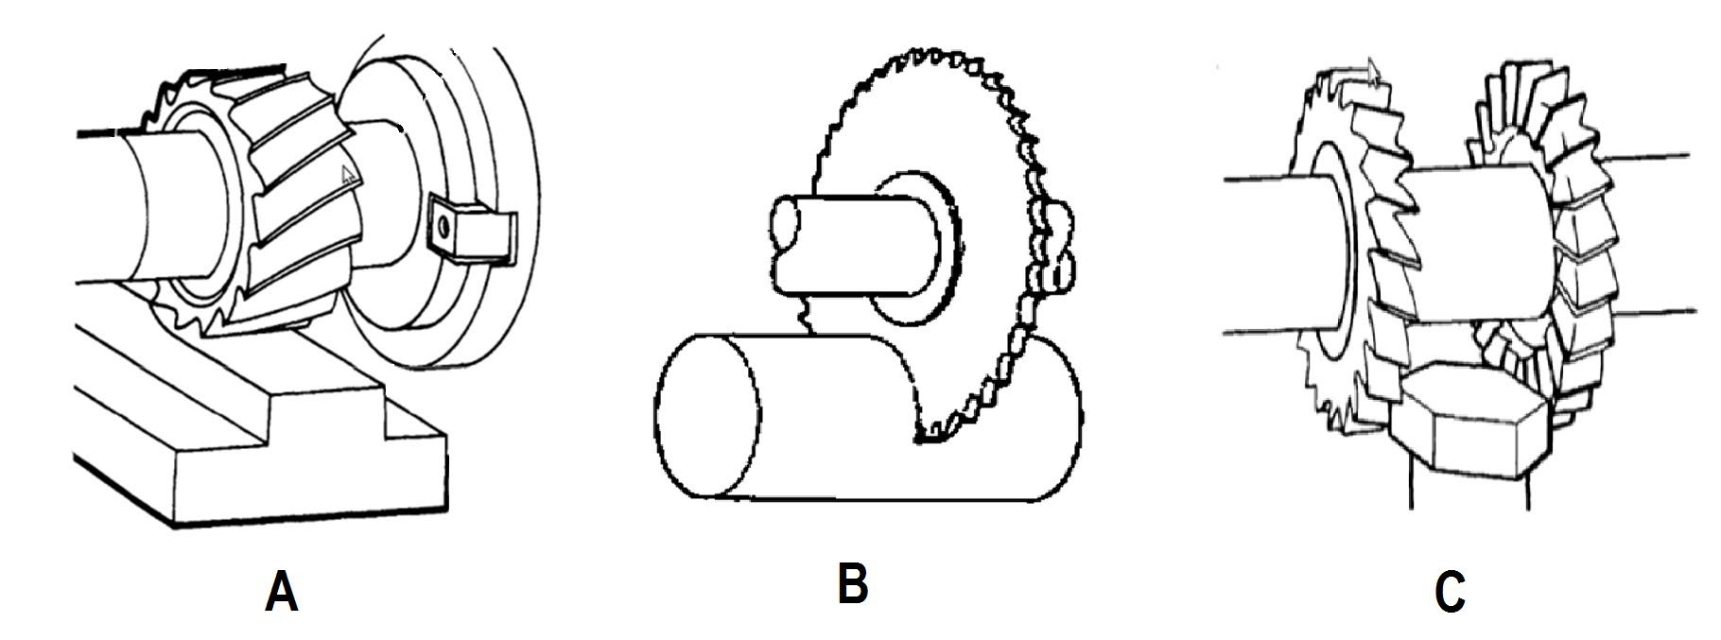

#### FIGURE 4

12.2.1 Name the milling cutters shown in FIGURE 4 by writing only the answer next to the letter (A–C) in the ANSWER BOOK. (3)

12.2.2 State the functions of milling cutters A, B and C shown in

FIGURE 4. (3)

12.3 A milling machine has to mill 18 teeth on a gear blank.

Calculate the required indexing using a Cincinnati dividing head.

|  |  |  |  |  |  |  |  |  |  |  |  |
| --- | --- | --- | --- | --- | --- | --- | --- | --- | --- | --- | --- |
|  |  | THE CINCINNATI DIVIDING HEAD | | | | | | |  |  |  |
| Side 1 | 24 | 25 | 28 | 30 | 34 | 37 | 38 | 39 | 41 | 42 | 43 |
| Side 2 | 46 | 47 | 49 | 51 | 53 | 54 | 57 | 58 | 59 | 62 | 66 |

(3)

12.4 Calculate the feed in mm/min of a 75 mm diameter cutter with 14 teeth and a feed of 0,08 per tooth. The cutting speed of the material is 25 m/min. (5)

12.5 State TWO functions of the dividing head. (2)

12.6 List THREE advantages of using helical cutters. (3)

#### [20]

**TOTAL SECTION B:**   **40**

**GRAND TOTAL:**  **100**

**FITTING AND MACHING THEORY N2**

#### FORMULA SHEET

ƒ =ƒ𝑡𝑡 × T × N

𝜋𝜋𝜋𝜋𝜋𝜋

S =

60

𝑆𝑆 = 𝜋𝜋DN

40

N

N

9°

𝜋𝜋 − 𝑑𝑑 𝑙𝑙𝑆𝑆𝑙𝑙𝑙𝑙𝑡𝑡ℎ 𝑜𝑜𝑜𝑜 𝑤𝑤𝑜𝑜𝑜𝑜𝑤𝑤𝑤𝑤𝑤𝑤𝑆𝑆𝑤𝑤𝑆𝑆

𝑆𝑆𝑆𝑆𝑡𝑡 − 𝑜𝑜𝑜𝑜𝑆𝑆𝑜𝑜 = ×

2 𝑙𝑙𝑆𝑆𝑙𝑙𝑙𝑙𝑡𝑡ℎ 𝑜𝑜𝑜𝑜 𝑡𝑡𝑡𝑡𝑤𝑤𝑆𝑆𝑜𝑜

𝜃𝜃 𝑋𝑋

𝑡𝑡𝑡𝑡𝑙𝑙 =

2 𝐿𝐿

𝐿𝐿𝑆𝑆𝑡𝑡𝑑𝑑𝑤𝑤𝑙𝑙𝑙𝑙 𝑡𝑡𝑙𝑙𝑙𝑙𝑙𝑙𝑆𝑆 = 90° − (𝐻𝐻𝑆𝑆𝑙𝑙𝑤𝑤𝐻𝐻 𝑡𝑡𝑙𝑙𝑙𝑙𝑙𝑙𝑆𝑆 + 𝑤𝑤𝑙𝑙𝑆𝑆𝑡𝑡𝑜𝑜𝑡𝑡𝑙𝑙𝑤𝑤𝑆𝑆 𝑡𝑡𝑙𝑙𝑙𝑙𝑙𝑙𝑆𝑆)

𝐹𝐹𝑜𝑜𝑙𝑙𝑙𝑙𝑜𝑜𝑤𝑤𝑤𝑤𝑙𝑙𝑙𝑙 𝑡𝑡𝑙𝑙𝑙𝑙𝑙𝑙𝑆𝑆 = 90° + (𝐻𝐻𝑆𝑆𝑙𝑙𝑤𝑤𝐻𝐻 𝑡𝑡𝑙𝑙𝑙𝑙𝑙𝑙𝑆𝑆 − 𝑤𝑤𝑙𝑙𝑆𝑆𝑡𝑡𝑜𝑜𝑡𝑡𝑙𝑙𝑤𝑤𝑆𝑆 𝑡𝑡𝑙𝑙𝑙𝑙𝑙𝑙𝑆𝑆)

𝐿𝐿𝑆𝑆𝑡𝑡𝑑𝑑 = 𝜋𝜋𝑜𝑜 𝑜𝑜𝑜𝑜 𝑠𝑠𝑡𝑡𝑡𝑡𝑜𝑜𝑡𝑡𝑠𝑠 × 𝑤𝑤𝑤𝑤𝑡𝑡𝑤𝑤ℎ